Cary First Christian Church Worship Live Stream Access

1. Go to www.caryfirst.org
2. Scroll down and then click on “Worship Live Stream.”
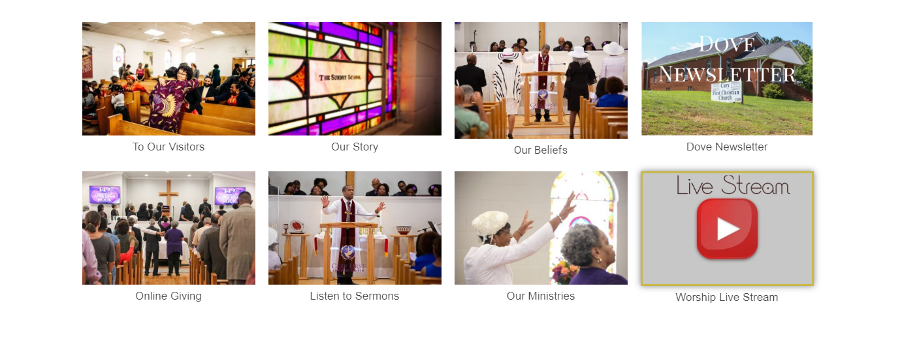
3. You will be directed to https://www.caryfirst.org/home/main-streaming/.
4. Once on this page you will see the stream for worship.
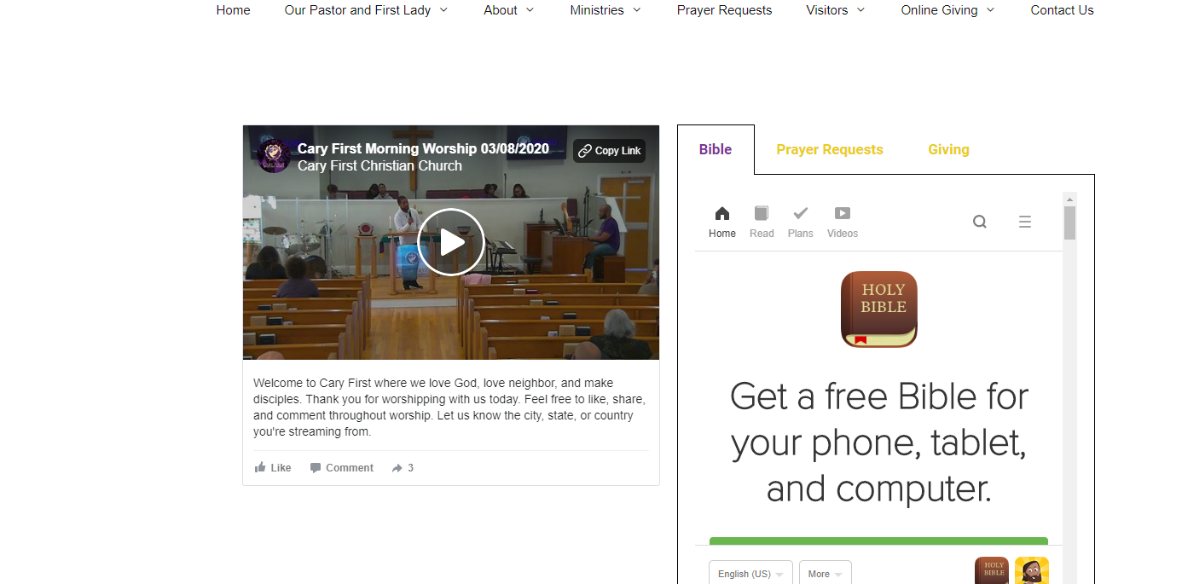
5. Click the play button at 10:30 a.m. to watch the worship service.

