Cary First Christian Church Online Giving Instructions

1. Go to www.caryfirst.org
2. Once on webpage, click “Online Giving.”
3. Once on the “Online Giving” page, scroll down and click the “Donate” button.
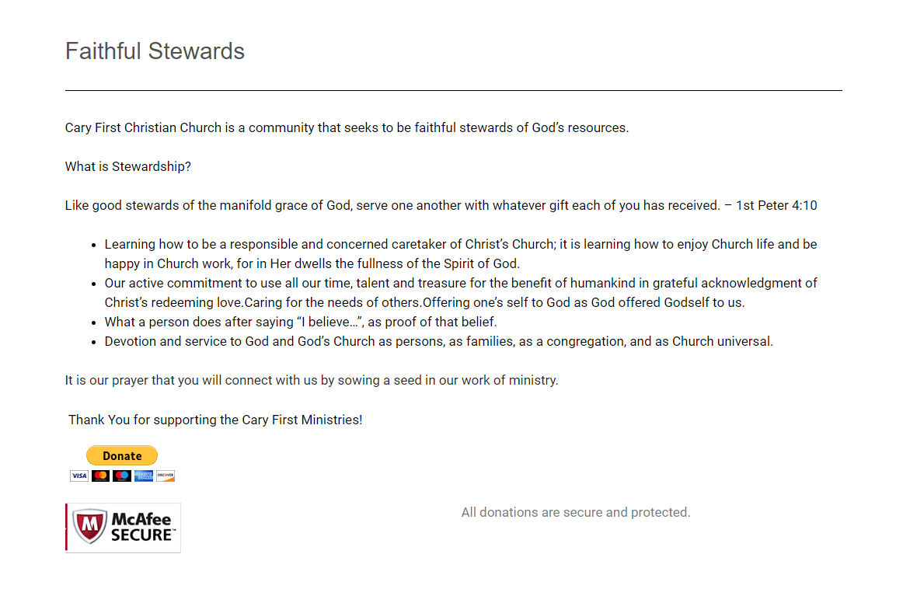
4. The “Donate” link will take you to the PayPal Giving Webpage.
5. Once on the PayPal giving webpage, type in the donation amount in the box.

6. After you have typed the donation amount click, “Donate with a Debit or Credit Card.”
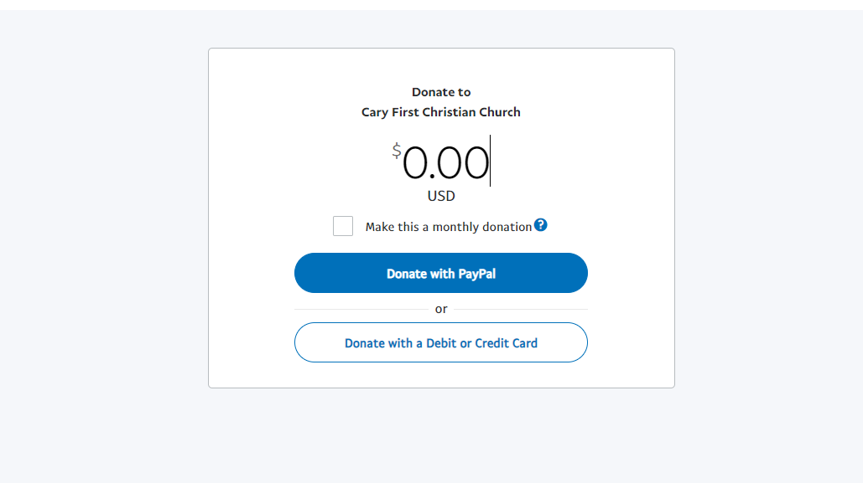

7. Once on the Donation confirmation page, type in all requested information.
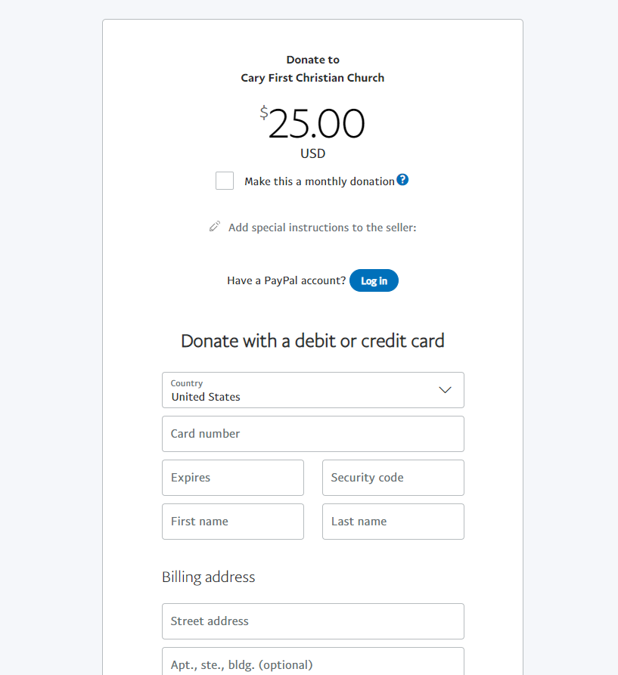
8. After all information has been entered, click “Donate Now.”
